|  |  |
| --- | --- |
| **Networking Infrastructure**  Diploma in CSF / IT  Apr 2022 Semester (Semester 3) | Week 11 |
| **Practical** |
| Configure VLANs in Layer 3 Switch | |

**Objectives**

At the end of this practical, student should be able to:

1. understand the basic concept of two VLANs in a switch;
2. understand how VLAN works
3. **Introduction**

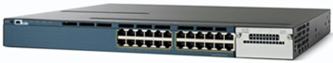

The Cisco **WS-C3560X-24T-S** Ethernet switch as shown above is a layer 3 switch. It has 24 switch ports providing the normal switching function. It can support Virtual LANs (VLAN). However, it also has basic routing functions, including static routing and the Routing Information Protocol (RIP). The switch ports can be configured to be router ports/interfaces to allow different subnets or networks to be connected to the switch.

**Note:**

Before configuring the Cisco 3560 switch, execute the command below to make sure that there are no VLAN configured on the switch.

#show vlan brief

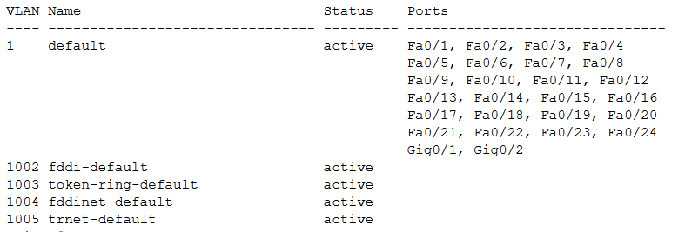

It means that the switch has no VLAN configured

(Proceed to 2. Configure the Catalyst 3560 to support VLANs)

1. **Configure the Catalyst 3560 to support VLANs**
   1. **Using default VLAN**

By default, the switch ports in the Catalyst 3560 are all in VLAN 1. Setup PC 1 and PC 3 as shown in Figure 2.

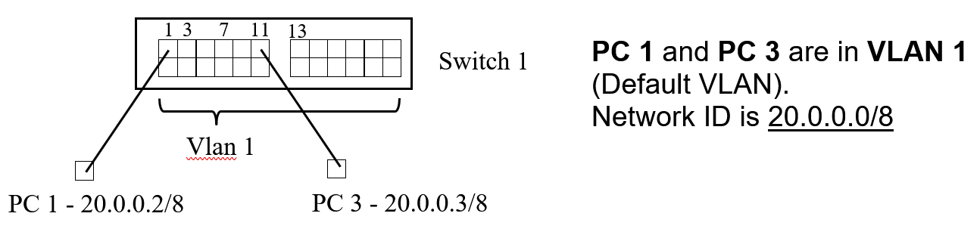

Figure 2

Before creating the VLANs, configure the following IP addresses for PCs:

|  |  |  |  |  |
| --- | --- | --- | --- | --- |
| **PC** | **Switch 1** | **VLAN (default)** | **IP Address** | **Subnet Mask** |
| PC 1 | 1 | VLAN 1 | 20.0.0.2 | 255.0.0.0 |
| PC 3 | 1 | VLAN 1 | 20.0.0.3 | 255.0.0.0 |

Show that PC 1 and PC 3 can ping each other as they are in the same physical switch, with the same IP network.

* 1. **Create VLANs**

By default, the switch ports in the Catalyst 3560 are all in VLAN 1. Create two VLANs namely vlan 2 and vlan 3 for the Sales and Admin department users respectively.

(config)#vlan 2 ; create a VLAN with vlan Id 2

(config-vlan)#name Sales ; name vlan 2 as Sales

(config-vlan)#end ; return to Privileged mode #

#show vlan brief ; show status of VLAN

(config)#vlan 3 ; create a VLAN with vlan Id 3

(config-vlan)#name Admin ; name vlan 3 as Admin

(config-vlan)#end ; return to Privileged mode #

#show vlan brief ; show status of VLAN

* 1. **Assign VLAN memberships to the switch ports**

1. vlan 2 has these member switch ports: Fa0/1 to Fa0/6

# config t

(config)#interface range Fa0/1-6 ; specify ports 1 to 6

(config-if-range)#switchport access vlan 2 ; place these ports into Vlan 2

(config-if-range)#no shut

(config-if-range)#end

#show vlan brief

1. vlan 3 has these member switch ports: Fa0/7 to Fa0/12

#config t

(config)#interface range Fa0/7-12 ; specify ports 7 to 12

(config-if-range)#switchport access vlan 3 ; place these ports into Vlan 3

(config-if-range)#no shut

(config-if-range)#end

#show vlan brief

* 1. **Testing Connectivity**

1. Test whether PC 1 and PC 3 can ping each other after you have configured both VLANs.

|  |  |  |  |  |
| --- | --- | --- | --- | --- |
| **PC** | **VLAN** | **IP Address** | **To PC 1:** | **To PC 3:** |
| PC 1 | vlan 2 | 20.0.0.2 |  | Unable to ping |
| PC 3 | vlan 3 | 20.0.0.3 | Unable to ping |  |

Explain the results.

After I configured the VLANs, PC1 and PC3 are not in different VLANs hence they are unable to see each other. Thus they cannot ping each other anymore.

1. Disconnect PC3 from port 11 and connect to port 6. Test whether PC 1 and PC 3 can ping each other.

|  |  |  |  |  |
| --- | --- | --- | --- | --- |
| **PC** | **VLAN** | **IP Address** | **To PC 1:** | **To PC 3:** |
| PC 1 | vlan 2 | 20.0.0.2 |  | Able to ping |
| PC 3 | vlan 2 | 20.0.0.3 | Able to ping |  |

Explain the results.

PC1 and PC3 can ping each other again because ports 1 to 6 belongs to VLAN 1 and now that PC3 is on port 6 and PC1 is on port 1, they are on the same VLAN meaning that they can see each and ping each other.